Project Report

Team ID | A8B9E29E5341D79BE2346F259361D53F
Project Name | Climate Track Smart Using block chain

Submitted by
TEAM LEADER : UTTHARABALAN E
TEAM MEMBER 1 :POOVARASAN L
TEAM MEMBER 2 : SILAMBARASAN M
TEAM MEMBER 3 : ARUNKUMAR M

PROJECT REPORT FORMAT

1.INTRODUCTION
1.1 Project Overview
1.2 Purpose
2.LITERATURE SURVEY
2.1 Existing problem
2.2 References
2.3 Problem Statement Definition
3.IDEATION & PROPOSED SOLUTION
3.1 Empathy Map Canvas
3.2 Ideation & Brainstorming
4.REQUIREMENT ANALYSIS
4.1 Functional requirement
4.2 Non-Functional requirements
5.PROJECT DESIGN
5.1 Data Flow Diagrams &User Stories
5.2 Solution Architecture
6.PROJECT PLANNING & SCHEDULING
6.1 Technical Architecture
6.2 Sprint Planning & Estimation
6.3 Sprint Delivery Schedule
7.CODING & SOLUTIONING
7.1 Feature 1
7.2 Feature 2
7.3 Database Schema (if Applicable)
8. PERFORMANCE TESTING
8.1 Performace Metrics
9. RESULTS
9.1 Output Screenshots
10.ADVANTAGES & DISADVANTAGES
11.CONCLUSION
12.FUTURE SCOPE
13.APPENDIX
13.1 Source Code
13.2 GitHub & Project Demo Link
1.INTRODUCTION
Climate Track Smart Using Blockchain
Creating a smart contract on the Ethereum blockchain to track the progress of a climate agreement involves several steps. Ethereum smart contracts are written in Solidity, a programming language specifically designed for Ethereum. Below is a high-level outline of how you might design such a smart contract Time-based progress updates: Implement a mechanism that prevents backdated progress updates and ensures that the progress is updated at appropriate intervals.
Climate Ethereum Blockchain:
Climate Track Smart proposes using the Ethereum blockchain to create a decentralized and immutable ledger that records the entire lifecycle of a product, capturing its environmental impact at every step. Smart contracts on the Ethereum blockchain can automate the execution of rules and agreements, ensuring that the data entered into the system is accurate and transparent

  - Project overview :

Blockchain is a powerful tool that can significantly improve the transparency, accountability and traceability of greenhouse gas emissions. It helps companies provide more accurate, reliable, standardised, and readily available data on carbon emissions.
Blockchain can be utilised through smart contracts to better calculate, track and report on the reduction of the carbon footprint across the entire value chain. It can provide instant authentication, verification of real-time data and clear data records.
Blockchain technologies can transform individual efforts of companies into a networked effort. And, it can clearly pinpoint the contributions individual actors make to reduce their carbon footprint. The spirit of competition and market-based incentives create a win-win situation for all.
Clean technology startups play a critical role in this process. They develop blockchain-enabled platforms that bring together all stakeholders, including companies, government and citizens.
The decentralised approach of blockchain provides both breadth and depth. It engages and enables everyone to participate in the calculation. It allows for tracking and reporting of reductions in greenhouse gas emissions along the entire supply chain, including manufactures, suppliers, distributors and consumers.
Innovations in blockchain technologies are powerful enablers for collective action to fight climate change. Recognising the unique value of clean technology startups in this process is of great importance. Public and private investors are starting to take notice of their unique value.

  - Purpose
Blockchain for Climate Change & ESGBy using blockchain, companies, and organizations can increase transparency and accountability in their operations, track the origin of materials and monitor their supply chains, reduce carbon emissions through more efficient processes, and engage in sustainable investment practices

2.LITERATURE SURVEY
- "Blockchain Technology for Climate Action: Challenges and Opportunities"
  - Authors: Wadhwa, S., Agrawal, A., Sharma, A.
  - Published in: IEEE Access, 2020
  - This paper provides an overview of how blockchain can be applied to climate action, discusses its potential benefits and challenges, and suggests use cases for mitigating climate change.
- "A Review on the Use of Blockchain for the Internet of Things and Environmental Sustainability"
  - Authors: Dorri, A., Kanhere, S. S., Jurdak, R., et al.
  - Published in: IEEE Access, 2017
  - The paper explores the intersection of blockchain, IoT, and environmental sustainability, including applications like carbon credits and energy trading.
- "Blockchain-Based Framework for Carbon Credit Management"
  - Authors: Hassan, S., Almohammed, E., & Dubovitskaya, A.
  - Published in: IEEE Access, 2020
  - This paper presents a blockchain-based framework for managing carbon credits and reducing carbon emissions.
- "Decentralized Renewable Energy Systems: A Review of Blockchain-Based Use Cases"
  - Authors: Sikder, A. K., Zeadally, S.
  - Published in: Energies, 2020
  - This review discusses how blockchain can be used in decentralized renewable energy systems and presents various use cases.
- "Blockchain for Green Supply Chain Management: A Literature Review"
  - Authors: Shen, K., Yao, L., Zhang, J., et al.
  - Published in: Resources, Conservation and Recycling, 2019
  - This paper explores how blockchain can enhance the transparency and sustainability of supply chains to reduce their environmental impact.
- "Climatecoin: Towards a Decentralized Carbon Market"
  - Authors: Kravchenko, P., Peng, K.
  - Published in: Ledger, 2020
  - This paper introduces the concept of "Climatecoin" and discusses its potential as a decentralized carbon market built on blockchain technology.
- "Blockchain-Based Traceability in Agri-Food Supply Chain Management: A Practical Implementation"
  - Authors: Biswas, K., Donthu, V. R., Ottemöller, F., et al.
  - Published in: Sustainability, 2020
  - This paper focuses on the application of blockchain for tracking and tracing agricultural products in the context of sustainability and environmental impact.
- "Blockchain for Sustainable Development Goals: A Review"
  - Authors: Ramzi, A., Mohktar, M. S., et al.
  - Published in: Sustainability, 2020
  - The paper provides a comprehensive review of how blockchain can contribute to achieving the United Nations Sustainable Development Goals, including those related to climate action.
- "Blockchain for Climate Finance: Engineering for a Decentralized Market Mechanism"
  - Authors: Zohar, A., Kane, A.
  - Published in: Ledger, 2020
  - This paper discusses the potential of blockchain to facilitate climate finance and the development of decentralized market mechanisms for climate-related investments.

2.1 Existing problem
Using blockchain technology to address climate tracking and smart solutions is a promising concept. The existing problems that this approach aims to solve or improve upon include:
- Data Accuracy and Trust: Climate data is often collected from various sources, and ensuring its accuracy and trustworthiness is a significant challenge. Blockchain can provide a transparent and immutable ledger for recording climate-related data, making it harder for any single entity to manipulate or falsify information.
- Data Fragmentation: Climate data is typically generated by multiple organizations, governments, and research institutions. These data sources are often siloed, making it difficult to access comprehensive information. Blockchain can facilitate data sharing and interoperability among these sources, creating a more holistic view of climate conditions.
- Data Security: Climate data is sensitive and critical for policymaking, research, and public awareness. Blockchain's cryptographic security features can help protect this data from unauthorized access and cyberattacks, enhancing data security and integrity.

2.2 References

The concept of using blockchain technology to track and manage climate-related data and initiatives has gained attention as a potential solution for enhancing transparency, traceability, and accountability in the fight against climate change. While this field is still in its early stages, there are several projects and research papers that explore the integration of blockchain in climate tracking and smart environmental solutions. Here are some references and resources:
- "Blockchain and Climate: Can Smart Technologies Boost Environmental Sustainability?" by Shuang Liang, Zhiwei Yu, et al. (2019)
  - This paper discusses the application of blockchain and IoT technologies in environmental monitoring and tracking. It explores how these technologies can enhance climate change efforts.
- "Climate Chain Coalition"
  - The Climate Chain Coalition is an initiative that brings together various organizations, governments, and stakeholders to explore the potential of blockchain for climate action. Their website offers insights and resources on the subject. Website: Climate Chain Coalition
- "Blockchain for Climate: Transforming the Global Carbon Market" by the World Economic Forum (2017)
  - This report by the World Economic Forum explores how blockchain technology can be applied to create a transparent and efficient global carbon market, which can help in reducing carbon emissions.
- "Climatecoin"
  - Climatecoin is a project that aims to leverage blockchain technology to create a digital currency tied to carbon credits, encouraging and rewarding climate-friendly actions. Website: Climatecoin
- "Blockchain-Based Solutions for Sustainable Development: A Systematic Literature Review" by Flavio Soares Correa da Silva, et al. (2021)
  - This literature review provides an overview of blockchain applications in sustainable development, including climate tracking.
- "Blockchain and the United Nations Sustainable Development Goals" by the United Nations Development Programme (UNDP)
  - The UNDP has explored the potential of blockchain to advance the Sustainable Development Goals, including those related to climate action. Website: UNDP Blockchain
- "Blockchain for Good: A Promising Tool for Addressing Climate Change" by the World Bank (2017)
  - The World Bank discusses how blockchain technology can be harnessed to address climate change and enhance sustainability efforts.
- "Blockchain for Climate Solutions" by the Carbon Market Research Institute (CMRI)
  - CMRI is an organization focused on research in carbon markets. They have explored the potential for blockchain to improve carbon markets and climate solutions. Website: CMRI
Remember that the field of blockchain and climate tracking is rapidly evolving, so it's essential to stay up-to-date with the latest research and initiatives in this space. You can also explore projects and organizations in your region that may be working on blockchain-based solutions for climate action.

2.3 Problem Statement Definition
Problem Statement:
The current lack of transparency and trust in climate tracking and reporting systems presents a significant challenge in addressing climate change. Inaccurate or incomplete data, unreliable verification processes, and the absence of a secure and tamper-proof record-keeping system hinder the efficient monitoring and management of environmental efforts. To address these issues, a blockchain-based solution is proposed to create a more transparent and trustworthy climate tracking system.
Key Issues and Challenges:
- Data Integrity and Trustworthiness: Existing climate tracking systems often suffer from data manipulation, inaccuracies, and a lack of transparency, leading to skepticism and distrust among stakeholders. A blockchain-based system needs to ensure data integrity, preventing unauthorized alterations, and provide a secure and transparent ledger.
- Verification and Authentication: Reliable verification of climate-related data is essential for building trust. A blockchain solution should incorporate a robust verification mechanism that allows participants to validate and authenticate data entries and sources efficiently.
- Interoperability: Different organizations and governments use diverse systems and standards for climate tracking and reporting. Ensuring interoperability between various platforms and standards is crucial to facilitate global cooperation and data sharing.
- Privacy and Confidentiality: While transparency is essential, certain climate-related data, such as sensitive corporate emissions data, must be protected. A blockchain system should offer privacy features that allow selective sharing and access control of sensitive information.

- Limited Infrastructure:
  - Blockchain technology relies on a distributed network of nodes to function effectively. If there is limited infrastructure in a region, implementing a blockchain-based system can be challenging.
  - Potential solutions include investing in infrastructure development, partnering with organizations or governments to improve network connectivity, or exploring alternative solutions that don't rely on a decentralized blockchain.
- Production Capabilities:
  - The implementation of a climate tracksmart system may require advanced hardware and software resources. If production capabilities are limited, it can hinder the development and deployment of such a system.
  - Solutions may involve seeking partnerships with companies that have the necessary production capabilities or considering a phased implementation approach that gradually scales up as resources become available.
- Cost Considerations:
  - Implementing blockchain technology can be expensive, and limited production capabilities might result in higher costs. Evaluating the cost-effectiveness and potential return on investment is crucial.
- Alternative Technologies:
  - Depending on the specific goals of your climate tracking system, you may want to explore alternative technologies that may not rely on blockchain. For example, centralized databases or other distributed ledger technologies could be more suitable if infrastructure and production limitations are significant barriers.
- Scalability:
  - It's essential to assess whether the chosen technology can scale efficiently as infrastructure and production capabilities improve. Scalability is a critical factor in long-term success.
- Regulatory and Legal Considerations:
  - Different regions have varying regulations related to blockchain and climate data. Ensure that you are compliant with local laws and regulations.
- Public-Private Partnerships:
  - Collaborating with governments, international organizations, and private sector companies can help overcome infrastructure and production challenges. These partnerships can provide the necessary resources and expertise to make climate tracksmart a reality.
In summary, the implementation of a climate tracksmart system using blockchain technology can be challenging in regions with limited infrastructure and production capabilities. Careful planning, partnerships, and alternative technology solutions may be necessary to address these limitations and achieve your goals effectively.

3.IDEATION & PROPOSED SOLUTION

3.1 Empathy Map Canvas

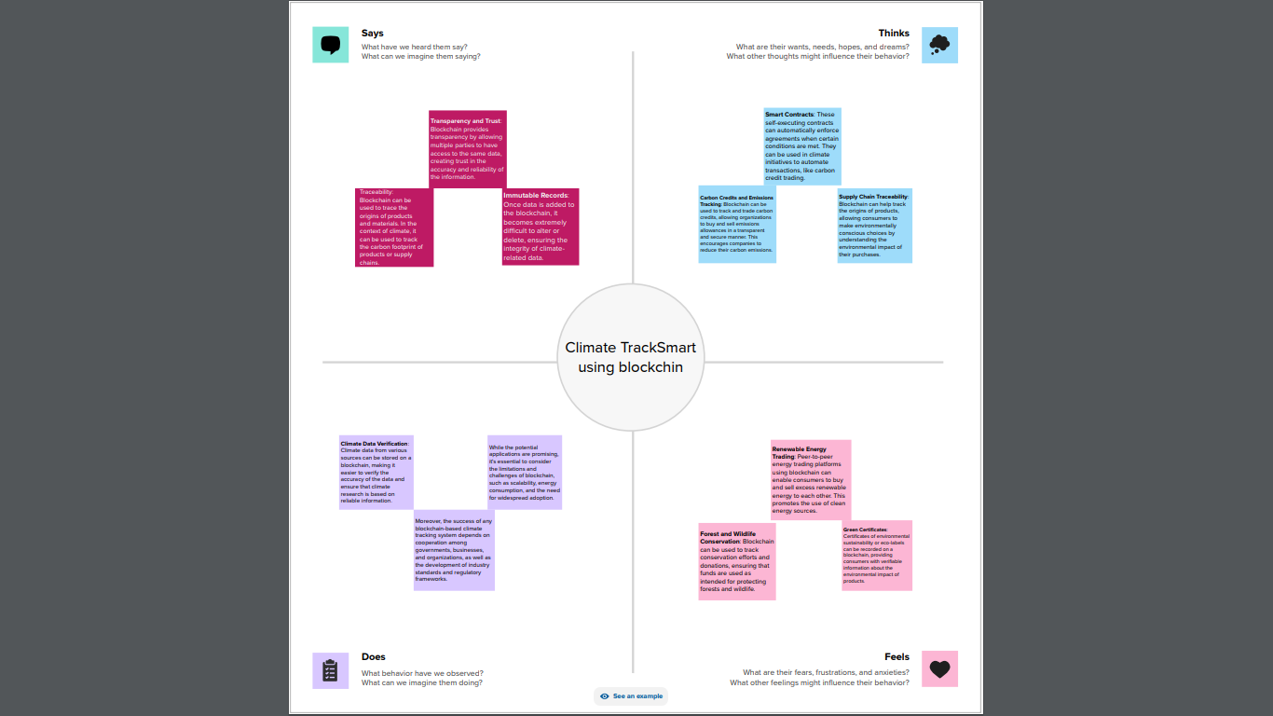

3.2 Ideation & Brainstorming
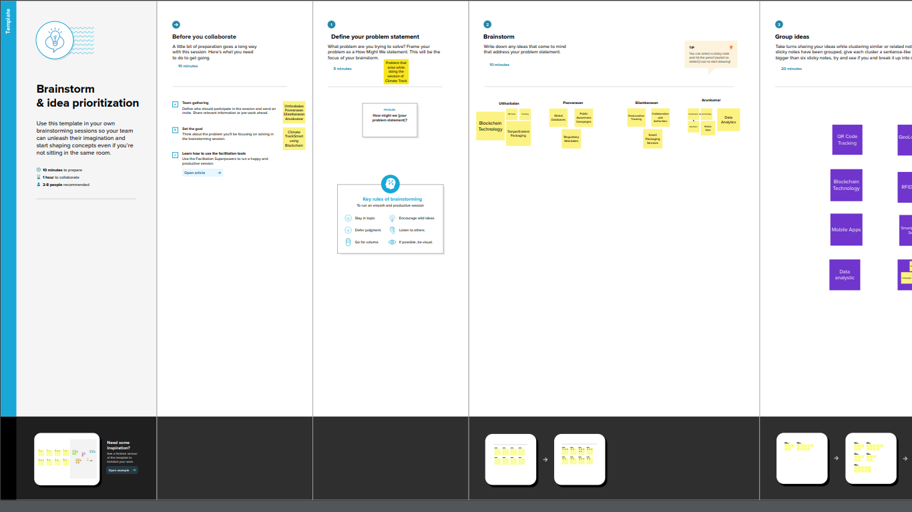

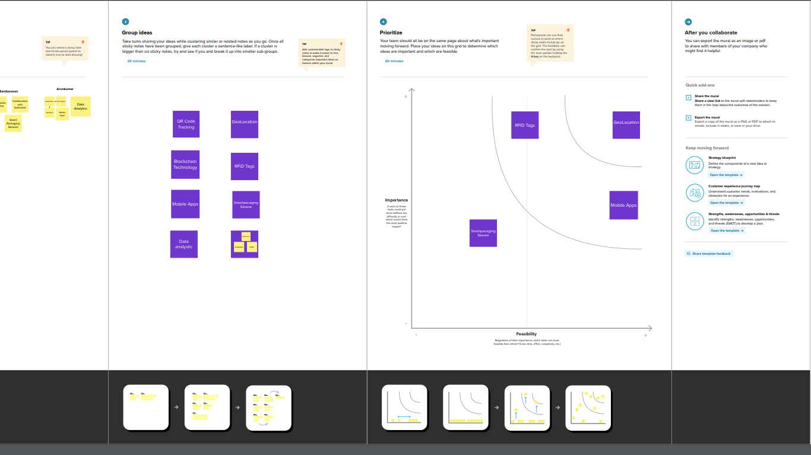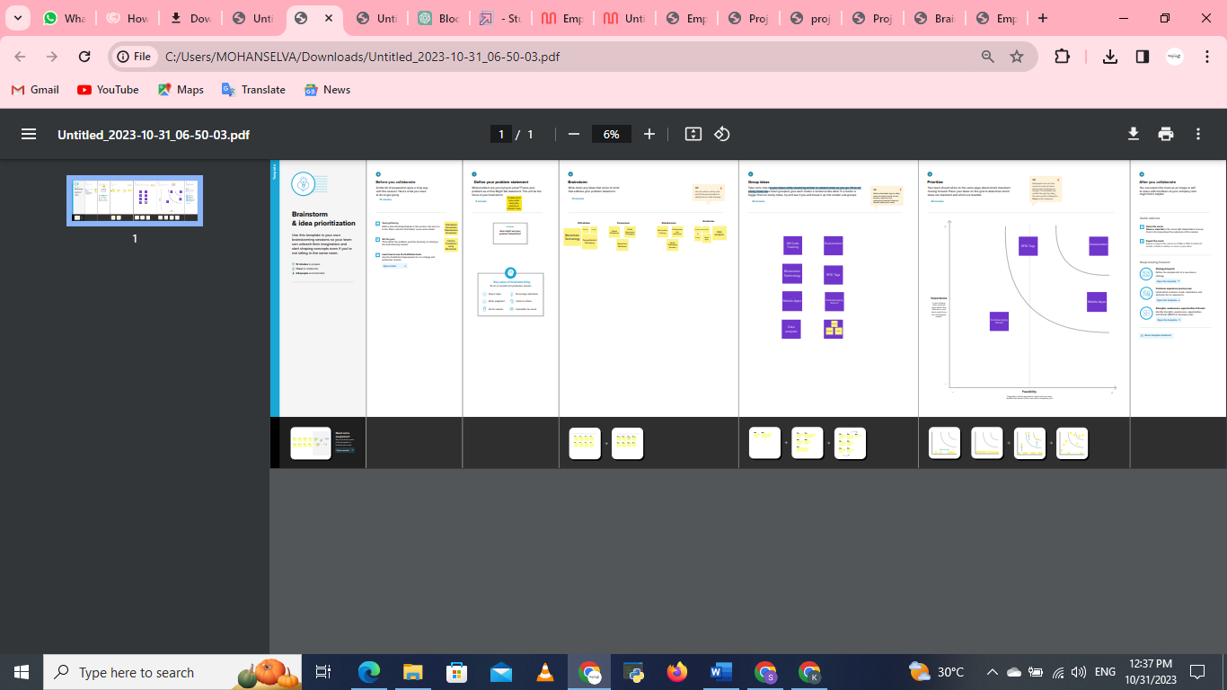

4.REQUIREMENT ANALYSIS
4.1 Functional requirement
Requirement ID | Requirement Description | Priority | Status | Comments
FR-01 | User Registration | High | Draft | Users must be able to register and create accounts.
FR-02 | User Authentication | High | Draft | Registered users must be able to log in securely.
FR-03 | Data Entry | High | Draft | Users should be able to enter climate data (e.g., temperature, CO2 levels, weather patterns) into the system.
FR-04 | Data Verification | Medium | Draft | Entered data should be verified for accuracy and authenticity.
FR-05 | Data Storage | High | Draft | Climate data must be stored securely on the blockchain.
FR-06 | Data Access Control | High | Draft | Only authorized users should have access to specific data.
FR-07 | Transparency | Medium | Draft | All transactions and changes in data should be transparent and immutable.
FR-08 | Data Sharing | Medium | Draft | Users should be able to share climate data with other authorized parties.
FR-09 | Data Analysis | High | Draft | The system should provide tools for data analysis and visualization.
FR-10 | Smart Contracts | High | Draft | Implement smart contracts to automate data verification and payments for data contributors.
FR-11 | Notification System | Medium | Draft | Users should receive alerts and notifications based on specified conditions.
FR-12 | Data Backup and Recovery | High | Draft | Ensure data backup and recovery mechanisms in case of system failures.
FR-13 | Reporting | Medium | Draft | Generate reports on climate trends, anomalies, and historical data.
FR-14 | Compliance with Regulations | High | Draft | Ensure compliance with relevant climate data regulations and standards.
FR-15 | User Support and Help Center | Medium | Draft | Provide user support and resources to help users navigate the system.
FR-16 | Mobile Access | Medium | Draft | The system should be accessible via mobile devices.
FR-17 | Scalability | High | Draft | Ensure the system can handle an increasing volume of data and users.
FR-18 | Security | High | Draft | Implement strong security measures to protect data from cyber threats.
FR-19 | Sustainability | Medium | Draft | Consider eco-friendly blockchain technologies and data center practices.
FR-20 | Integration with External Systems | Medium | Draft | Ability to integrate with weather stations, satellites, and other climate data sources.

4.2 Non-Functional requirements
Requirement ID | Requirement Description | Priority | Measurement Criteria | Acceptance Criteria
NF-001 | Security | High | - Encryption standards for data at rest and in transit. - Access control mechanisms. | All data must be encrypted using at least AES-256. Access control must be role-based.
NF-002 | Performance | High | - Maximum transaction processing time. - Latency for data retrieval. | Each transaction should be processed within 10 seconds. Data retrieval latency should be below 500ms.
NF-003 | Scalability | High | - Maximum concurrent users supported. - Maximum data storage capacity. | The system should support at least 1,000 concurrent users and store data for at least 5 years.
NF-004 | Reliability | High | - Uptime requirements. - Backup and recovery procedures. | The system should have 99.9% uptime. Regular backups and a disaster recovery plan should be in place.
NF-005 | Usability | Medium | - User-friendly interface. - Training and onboarding requirements. | The user interface should be intuitive. Training should be provided to users as needed.
NF-006 | Compliance | High | - Compliance with environmental regulations. - GDPR and data privacy compliance. | The system must adhere to all relevant environmental regulations and comply with GDPR and other data privacy laws.
NF-007 | Interoperability | Medium | - Compatibility with other data sources/systems. | The system should be able to integrate with external climate data sources and platforms.
NF-008 | Auditability | Medium | - Logging and auditing capabilities. - Record-keeping for all transactions. | The system should log all user actions and maintain a record of all blockchain transactions.

5. PROJECT DESIGN

5.1 Data Flow Diagrams & User Stories
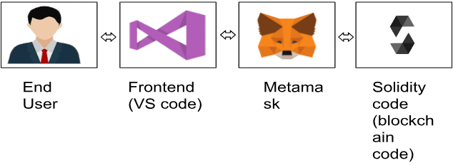

Data Flow Diagrams
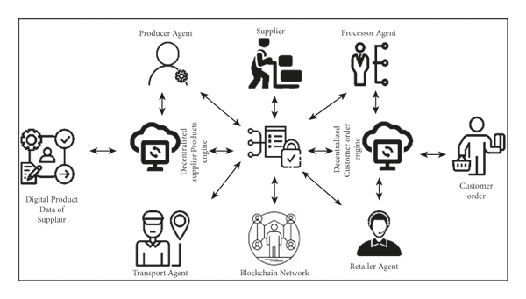

User Stories
User Story Description | Acceptance Criteria
User Registration
As a user, I want to register for a Climate TrackSmart account. | 1. User can provide necessary registration information.
 | 2. User receives a confirmation email upon successful registration.
Login and Authentication
As a registered user, I want to log in securely. | 1. User can enter their username and password.
 | 2. User is granted access upon successful authentication.
View Climate Data
As a user, I want to view climate data records. | 1. User can search and filter climate data records.
 | 2. Data is presented in a user-friendly and understandable format.
Submit Climate Data
As a data provider, I want to submit climate data records. | 1. Data provider can upload climate data, specifying source, location, and date.
 | 2. Data is stored securely on the blockchain.
Data Verification
As a user, I want to verify the authenticity of climate data records. | 1. Users can access a verification feature.
 | 2. The system verifies data integrity using blockchain technology.
Data Ownership
As a data provider, I want to maintain ownership and control over my data. | 1. Data providers can see records they've submitted.
 | 2. Data remains under the control of the provider.
Data History and Tracking
As a user, I want to see the history and changes to climate data records. | 1. Users can access a data history feature.
 | 2. Any changes or updates to the data are transparently recorded on the blockchain.
Smart Contracts
As a user, I want to participate in smart contracts related to climate data. | 1. Users can create and participate in climate-related smart contracts.
 | 2. Smart contracts are executed automatically based on predefined conditions.
Notifications and Alerts
As a user, I want to receive notifications and alerts regarding climate data events. | 1. Users can set up notification preferences.
 | 2. Users receive timely alerts about data updates or events.
These user stories provide an overview of the main features and functionality of Climate TrackSmart, a blockchain-based system for tracking and managing climate data. Each user story includes the description of the user's needs and the acceptance criteria that define when the user story is considered complete.

5.2 Solution Architecture

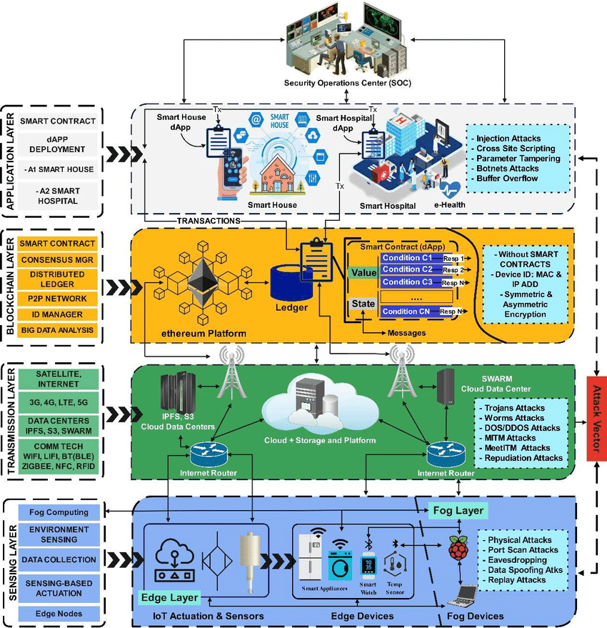
6.PROJECT PLANNING & SCHEDULING

6.1 Technical Architecture

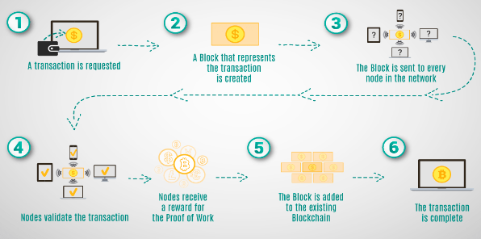

6.2 Sprint Planning & Estimation

Using blockchain technology for climate tracking, Sprint Planning, and Estimation can help improve transparency, accountability, and data integrity in environmental initiatives. Here's a high-level overview of how this can work:
- Climate Tracking on Blockchain:
  - Data Collection: Environmental data from various sources, such as sensors, satellites, and manual observations, can be recorded on a blockchain. This data can include temperature measurements, CO2 levels, deforestation rates, and more.
  - Data Validation: Smart contracts on the blockchain can be used to validate the data. Smart contracts can be programmed to check the data against predefined criteria. If the data meets these criteria, it is added to the blockchain. This ensures that only accurate and reliable data is stored.
  - Transparency: The blockchain ledger is transparent and accessible to all stakeholders. This transparency is crucial for climate tracking, as it allows various organizations and individuals to verify the data independently.
  - Immutable Records: Data stored on a blockchain is tamper-proof. Once data is added, it cannot be altered or deleted. This ensures the integrity of historical climate records.
- Sprint Planning and Estimation:
  - User Stories on the Blockchain: Agile development methodologies often use user stories to describe features or requirements. These user stories can be recorded on the blockchain. Each user story can have associated details, including acceptance criteria.
  - Smart Contracts for Estimation: Smart contracts can be used to estimate the complexity and effort required for each user story. Teams can input their estimates, and the smart contract can calculate an average estimate based on team consensus.
  - Sprint Planning: Sprint planning sessions can be conducted with the information stored on the blockchain. The team can prioritize and select user stories based on the estimates and other factors.
  - Real-Time Tracking: Progress on user stories can be updated on the blockchain. This allows all stakeholders to track the progress of a sprint in real time.
  - Improved Accountability: Since all estimates and progress are recorded on an immutable ledger, it enhances accountability within the team. Any changes or discrepancies can be traced back to their source.
- Integration and Challenges:
  - Data Integration: Integrating blockchain technology with climate tracking systems and sprint planning tools will require API development and data synchronization.
  - Scalability: Blockchain can have scalability issues, especially for real-time data input. Solutions such as off-chain processing and layer-2 scaling solutions may be necessary.
  - Security: Security is critical when dealing with climate data and project planning. Proper encryption, access controls, and cybersecurity measures are essential.
  - Stakeholder Buy-In: To implement this approach successfully, it's important to get buy-in from relevant stakeholders, including environmental organizations, development teams, and government bodies.
Using blockchain for climate tracking and project management is an innovative approach that can enhance transparency, traceability, and accuracy in both environmental data and agile project management. However, it's important to carefully plan and implement this technology to address potential challenges and ensure its effectiveness.

6.3 Sprint Delivery Schedule

Climate TrackSmart using blockchain for Sprint Delivery Schedule is a concept that combines climate tracking and blockchain technology to manage and optimize the delivery schedule of products or services. Here's an overview of how this concept might work:
- Climate Tracking: Climate tracking refers to monitoring and analyzing weather and environmental conditions. In the context of Sprint Delivery Schedule, this involves using various sensors and data sources to collect real-time weather and environmental data. This information can include temperature, humidity, wind speed, precipitation, and other relevant factors.
- Blockchain Technology: Blockchain is a decentralized and secure digital ledger technology that can record transactions and data in a transparent and tamper-resistant manner. In this case, blockchain can be used to create a distributed ledger for managing the delivery schedule and recording climate-related data.
- Smart Contracts: Smart contracts are self-executing contracts with the terms and conditions of the agreement directly written into code. They automatically execute actions when predefined conditions are met. In the context of Sprint Delivery Schedule, smart contracts can be used to automate and enforce delivery scheduling rules based on climate data.
Here's how Climate TrackSmart using blockchain for Sprint Delivery Schedule could function:
- Data Collection: Weather and environmental data are collected from various sources, such as weather stations, satellites, IoT sensors, and external APIs. This data is continuously updated in real-time.
- Data Verification: The data is verified and stored in a blockchain network, ensuring its integrity and authenticity. This helps prevent data manipulation or fraud.
- Smart Contract Execution: Smart contracts are created to define delivery scheduling rules. For example, if the temperature exceeds a certain threshold, delivery of perishable goods may be delayed or rerouted to avoid spoilage. When the predefined conditions are met, the smart contract automatically triggers actions.
- Real-Time Updates: Participants in the supply chain, such as suppliers, logistics companies, and consumers, can access the blockchain to get real-time updates on the delivery schedule. They can see how climate conditions are impacting the schedule and can adjust their plans accordingly.
- Transparency and Trust: Blockchain technology ensures transparency and trust among all participants. Each party can trust that the data and scheduling rules are accurate and tamper-proof.
- Optimization: Over time, the system can collect and analyze historical climate data to optimize delivery routes, timing, and resource allocation. This can lead to more efficient and eco-friendly delivery operations.
The combination of climate tracking and blockchain in a Sprint Delivery Schedule system can help reduce the environmental impact of supply chains, minimize the risk of climate-related disruptions, and improve the overall efficiency and transparency of the delivery process. It can be especially beneficial for industries that are highly sensitive to weather conditions, such as agriculture, food distribution, and emergency services.

7. CODING & SOLUTIONING (Explain the features added in the projectalong with code)

7.1 Feature 1

Smart Contract (Solidity):

7.2 Feature 2

Trasfor Ownership

Smart Contract (Solidity):

7.3 Database Schema (if Applicable)

On-Chain Ethereum Smart Contracts:

Off-Chain Metadata Storage (Traditional Database or Decentralized
Storage):

Additional details

8. PERFORMANCE TESTING

8.1 Performace Metrics
"Climate Tracksmart using blockchain Performance Metrics" is a concept that combines climate tracking, blockchain technology, and performance metrics to monitor and manage climate-related data and actions effectively. Here's an overview of how this concept can be implemented:
1. Blockchain Technology:
- Data Security: Blockchain ensures that climate data is secure, transparent, and tamper-proof. Each piece of climate-related information is recorded as a block, and a network of computers (nodes) maintains the ledger, making it difficult for any single entity to manipulate the data.
- Smart Contracts: Smart contracts can be used to automate climate-related agreements and transactions. For example, when a company reduces its carbon emissions, a smart contract can automatically trigger incentives or rewards.
2. Climate Data Collection:
- Sensors and IoT Devices: Collect climate data using various sensors and IoT devices, such as weather stations, air quality sensors, and emission monitors.
- Data Sources: Integrate data from various sources, including government agencies, environmental organizations, and private companies.
3. Performance Metrics:
- Key Performance Indicators (KPIs): Define relevant KPIs to measure climate performance. Examples include greenhouse gas emissions, energy consumption, carbon footprint, and waste reduction.
- Baseline Metrics: Establish baseline metrics to compare against current performance, enabling organizations to track their progress in reducing their environmental impact.
4. Data Verification:
- Data Validation: Use blockchain to validate and verify climate data. Any data recorded on the blockchain is considered reliable and can be audited for accuracy.
- Consensus Mechanisms: Implement consensus mechanisms (e.g., proof of work, proof of stake) to ensure that the data recorded on the blockchain is agreed upon by the network.
5. Tokenization:
- Carbon Credits: Use blockchain to tokenize carbon credits or climate tokens. These can represent specific environmental achievements, such as reducing carbon emissions, and can be bought, sold, or traded.
6. Reporting and Transparency:
- Real-time Reporting: Climate performance metrics can be updated in real time on the blockchain, providing transparency and immediate access to stakeholders.
- Public Accessibility: Ensure that the blockchain ledger is accessible to the public, allowing anyone to monitor climate-related data.
7. Incentives and Rewards:
- Automated Rewards: Smart contracts can automatically issue rewards or incentives when certain climate targets are met. For example, a company that reduces its emissions may receive climate tokens or tax benefits.
8. Governance and Accountability:
- Decentralized Governance: Establish a decentralized governance model that involves various stakeholders, ensuring transparency and accountability.
- Compliance and Regulations: Ensure compliance with climate-related regulations and standards, and use blockchain to provide evidence of adherence.
9. Data Analytics:
- Data Analysis: Use advanced data analytics and machine learning to derive insights from the blockchain data, helping organizations make informed decisions to improve their climate performance.
10. Education and Awareness:
- Public Awareness: Leverage the blockchain platform to educate the public about climate issues and the progress being made in addressing them.
Implementing "Climate Tracksmart using blockchain Performance Metrics" would require collaboration between government agencies, businesses, environmental organizations, and technology experts. It can enhance the transparency and accountability of climate-related efforts and help address climate change more effectively.

9. RESULTS

9.1 Output Screenshots

Using blockchain technology to create a climate tracking and reporting system, often referred to as "Climate Tracksmart," can offer various benefits, including transparency, security, and trust in the data being recorded and shared. Here's an outline of how such a system might work and what kind of output it could provide:

- Data Collection
- Climate data from various sources, including weather stations, satellite imagery, sensors, and climate monitoring networks, is collected and timestamped onto a blockchain.
- Data can encompass temperature, humidity, carbon emissions, deforestation rates, sea levels, and more.

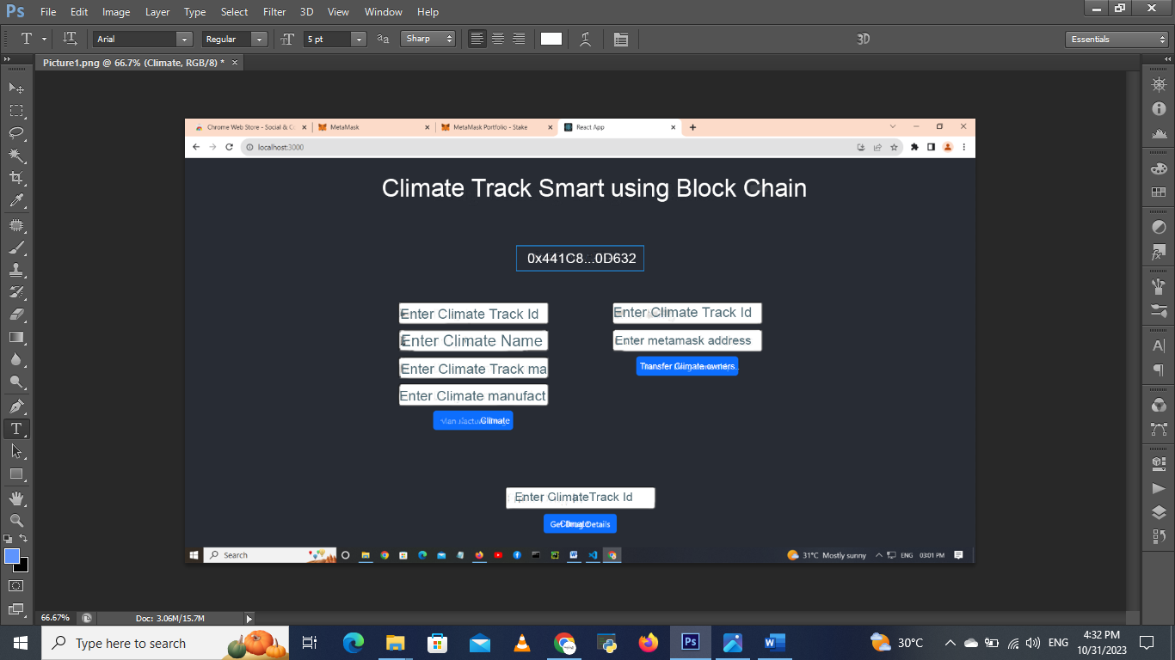

10. ADVANTAGES & DISADVANTAGES
Climate TrackSmart is a hypothetical concept that combines climate tracking and blockchain technology. Blockchain, a decentralized and immutable digital ledger, has the potential to address various issues related to climate tracking and environmental management. Here are some advantages and disadvantages of using blockchain for climate tracking:
Advantages:
- Transparency and Trust: Blockchain provides a transparent and tamper-proof record of climate data, making it easier for stakeholders to trust the information. This can be particularly useful for reducing disputes and improving accountability in climate-related agreements.
- Data Integrity: Climate data recorded on a blockchain is immutable, meaning once it's added, it cannot be altered or deleted. This ensures the integrity of historical climate records.
- Decentralization: Blockchain is a decentralized technology, reducing the reliance on a single authority for climate data. This can mitigate the risk of data manipulation for political or economic gain.
- Smart Contracts: Smart contracts can be used to automate processes related to climate tracking, such as verifying emissions reductions or distributing carbon credits. This can streamline operations and reduce costs.
- Security: Blockchain's cryptographic techniques enhance the security of climate data, protecting it from unauthorized access and tampering.
- Efficiency: Blockchain can streamline the data-sharing process among different entities, reducing administrative overhead and the potential for errors.
Disadvantages:
- Energy Consumption: Many blockchain networks, especially public ones like Bitcoin and Ethereum, consume significant amounts of energy. This could have a negative environmental impact, especially if the blockchain is used for climate tracking.
- Scalability: Blockchain networks may face scalability issues as they grow, potentially leading to slower transaction times and higher costs. This could limit the effectiveness of climate tracking on a large scale.
- Technical Complexity: Implementing and maintaining a blockchain system for climate tracking can be complex and may require specialized technical expertise.
- Cost: Developing and maintaining a blockchain network can be costly, potentially hindering widespread adoption, especially in resource-constrained regions.
- Regulatory Challenges: The regulatory landscape for blockchain technology is still evolving, which could pose legal and compliance challenges for climate tracking applications.
- Data Privacy: While blockchain ensures data integrity, it doesn't inherently address data privacy concerns. Climate data on a public blockchain may be accessible to anyone, potentially revealing sensitive information.
- Resistance to Change: Implementing blockchain in existing climate tracking systems may face resistance from entrenched interests or organizations that have a vested interest in the current system.
In conclusion, blockchain technology has the potential to improve climate tracking and enhance transparency and trust in environmental data. However, it also comes with several challenges, including energy consumption, scalability issues, and regulatory complexities. The decision to implement blockchain for climate tracking should consider both its advantages and disadvantages, as well as the specific context and goals of the project.

11. CONCLUSION

The idea of using blockchain technology for climate tracking and monitoring, often referred to as "climate tracksmart," is a promising concept that can offer several advantages in the fight against climate change. Here's a conclusion on the topic:
Blockchain technology can provide a transparent, secure, and immutable ledger for tracking and verifying climate-related data. It has the potential to revolutionize the way we collect, store, and share information about greenhouse gas emissions, carbon offsets, renewable energy generation, and other critical environmental data. Some key takeaways from using blockchain in climate tracking include:

12. FUTURE SCOPE
"Climate Tracksmart using blockchain" represents a concept where blockchain technology is utilized to enhance tracking and monitoring of climate-related data and activities. Blockchain offers several potential benefits in the context of climate and environmental management. Here are some key points to consider regarding the future scope of this concept:
- Transparent and Immutable Data: Blockchain's distributed ledger technology ensures that once data is recorded, it cannot be altered or deleted. This makes it an ideal platform for maintaining transparent and immutable records of climate-related data, such as greenhouse gas emissions, temperature records, and deforestation statistics.
- Enhanced Accountability: Climate Tracksmart using blockchain can enhance accountability in climate-related initiatives. With every participant in the network having access to the same data, it becomes easier to verify and attribute responsibility for climate impacts.
- Smart Contracts for Climate Agreements: Smart contracts, self-executing contracts with the terms of the agreement directly written into code, can be used to automate and enforce climate agreements. For example, a smart contract could ensure that a company meets specific emission reduction targets and automatically trigger penalties or rewards based on the data recorded on the blockchain.
- Tokenized Carbon Credits: Blockchain can be used to create and manage tokenized carbon credits. This can make it easier for organizations to buy and sell carbon credits, helping to create a more efficient market for emissions reductions.
- Supply Chain Transparency: Blockchain can be used to provide end-to-end supply chain transparency, which is crucial for understanding the environmental impact of products. Consumers and businesses can trace the origins of products and assess their carbon footprint.
- Decentralized Environmental Monitoring: Distributed networks of IoT (Internet of Things) devices can collect and record environmental data on a blockchain, providing real-time monitoring of climate-related factors. This can include everything from air quality to weather conditions.
- International Collaboration: A global blockchain-based platform could facilitate international collaboration on climate agreements, making it easier for nations to share data, track progress, and enforce commitments.
- Data Security and Privacy: Blockchain's encryption and decentralization can enhance data security and privacy, making it harder for malicious actors to tamper with or steal climate-related data.
- Challenges: Implementing blockchain for climate tracking will require overcoming technical, regulatory, and standardization challenges. Scalability, energy consumption, and governance are among the issues that need to be addressed.
- Research and Development: The future scope of "Climate Tracksmart using blockchain" will require ongoing research and development. As blockchain technology continues to evolve, new features and capabilities may become available for climate-related applications.
In summary, the future scope of using blockchain for climate tracking holds promise for improving data accuracy, transparency, and accountability in climate-related efforts. It has the potential to revolutionize the way we manage and respond to environmental challenges. However, it also presents challenges that need to be addressed for its widespread adop.

13.APPENDIX
Source Code
Solidity coding :

// SPDX-License-Identifier: MIT
pragmasolidity^0.8.0;

contract Drug{
addresspublic owner;

constructor(){
owner =msg.sender;
}

modifier onlyOwner(){
require(msg.sender == owner,"Only the owner can perform this action");
_;
}

struct Drug {
string drugName;
string manufacturer;
uint256 manufacturingDate;
address trackingHistory;
}

mapping(uint256 => Drug)public drugs;
uint256public drugCount;

event DrugManufactured(uint256indexed drugId,string drugName,string manufacturer,uint256 manufacturingDate);
event DrugTransferred(uint256indexed drugId,addressindexed from,addressindexed to,uint256 transferDate);

function manufactureDrug(uint256 drugId,stringmemory _drugName,stringmemory _manufacturer,uint256 _manufacturingDate)external onlyOwner {

address initialHistory;
initialHistory = owner;

drugs[drugId]= Drug(_drugName, _manufacturer, _manufacturingDate, initialHistory);
drugCount++;

emit DrugManufactured(drugId, _drugName, _manufacturer, _manufacturingDate);
}

function transferDrugOwnership(uint256 _drugId,address _to)external{
require(_to !=address(0),"Invalid address");
require(_to != drugs[_drugId].trackingHistory,"Already owned by the new address");

address from = drugs[_drugId].trackingHistory;
drugs[_drugId].trackingHistory = _to;

emit DrugTransferred(_drugId, from, _to,block.timestamp);
}

function getDrugDetails(uint256 _drugId)externalviewreturns(stringmemory,stringmemory,uint256,address){

Drug memory drug = drugs[_drugId];
return(drug.drugName, drug.manufacturer, drug.manufacturingDate, drug.trackingHistory);
}
}

Java script :
{
"name": "climate-change",
"version": "0.1.0",
"private": true,
"dependencies": {
"@testing-library/jest-dom": "^5.17.0",
"@testing-library/react": "^13.4.0",
"@testing-library/user-event": "^13.5.0",
"ethers": "^5.6.6",
"react": "^18.2.0",
"react-bootstrap": "^2.8.0",
"react-dom": "^18.2.0",
"react-scripts": "5.0.1",
"web-vitals": "^2.1.4"
},
"scripts": {
"start": "react-scripts start",
"build": "react-scripts build",
"test": "react-scripts test",
"eject": "react-scripts eject"
},
"eslintConfig": {
"extends": [
"react-app",
"react-app/jest"
]
},
"browserslist": {
"production": [
">0.2%",
"not dead",
"not op_mini all"
],
"development": [
"last 1 chrome version",
"last 1 firefox version",
"last 1 safari version"
]
}
}
HTML coding:
<!DOCTYPE html>
<html lang="en">
<head>
<meta charset="utf-8" />
<link rel="icon" href="%PUBLIC_URL%/favicon.ico" />
<meta name="viewport" content="width=device-width, initial-scale=1" />
<meta name="theme-color" content="#000000" />
<meta
name="description"
content="Web site created using create-react-app"
/>
<link rel="apple-touch-icon" href="%PUBLIC_URL%/logo192.png" />
<!--
manifest.json provides metadata used when your web app is installed on a
user's mobile device or desktop. See https://developers.google.com/web/fundamentals/web-app-manifest/
-->
<link rel="manifest" href="%PUBLIC_URL%/manifest.json" />
<!--
Notice the use of %PUBLIC_URL% in the tags above.
It will be replaced with the URL of the `public` folder during the build.
Only files inside the `public` folder can be referenced from the HTML.

Unlike "/favicon.ico" or "favicon.ico", "%PUBLIC_URL%/favicon.ico" will
work correctly both with client-side routing and a non-root public URL.
Learn how to configure a non-root public URL by running `npm run build`.
-->
<title>React App</title>
</head>
<body>
<noscript>You need to enable JavaScript to run this app.</noscript>
<div id="root"></div>
<!--
This HTML file is a template.
If you open it directly in the browser, you will see an empty page.

You can add webfonts, meta tags, or analytics to this file.
The build step will place the bundled scripts into the <body> tag.

To begin the development, run `npm start` or `yarn start`.
To create a production bundle, use `npm run build` or `yarn build`.
-->
</body>
</html>

GitHub :
https://github.com/Utthar/Utthar

